**Elvira Zhukova - QA Engineer** 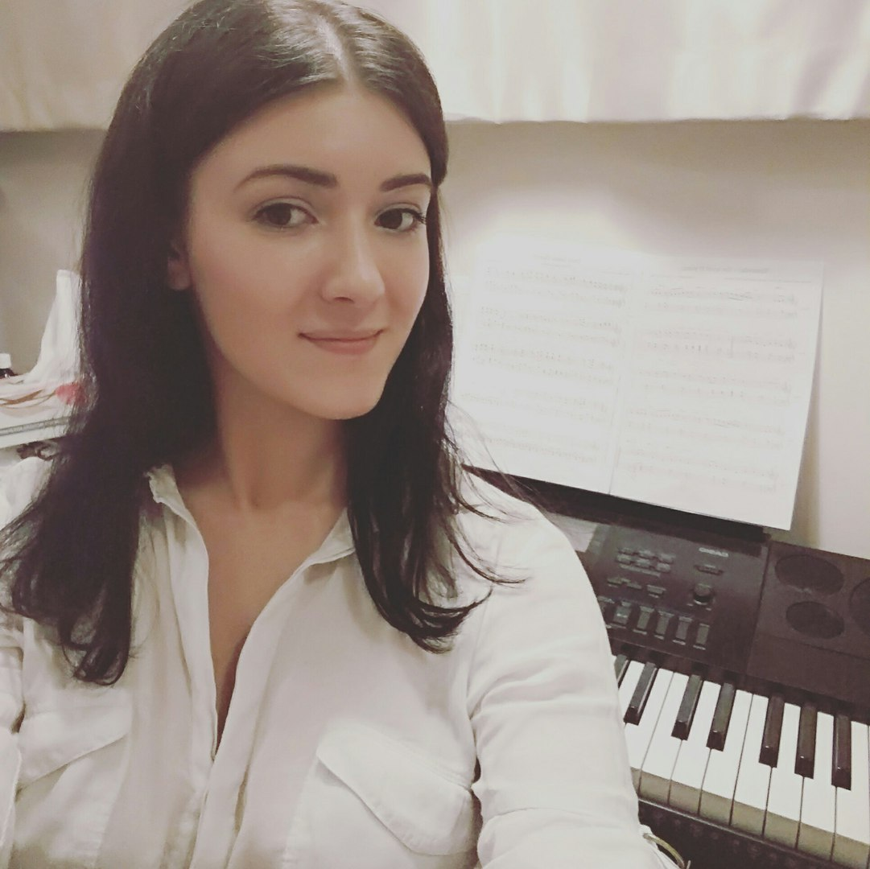

Odessa, Ukraine

**Cell:** +380631726835

**Mail:** [lepehova.elvira@gmail.com](mailto:lepehova.elvira@gmail.com)

**Skype:** babyblue_941

**Personal Summary:**

3+ years of successful work in IT-industry as QA Engineer.

Worked in big teams and as only QA in the project.

Fast-learner, can master new technologies in a short period of time.

Disciplined, can organize myself and my team.

**Professional Skills:**

* Excellent interpersonal and communication skills, team player;
* Upper intermediate spoken and written English;
* Good knowledge in manual (black, gray, white box) testing;
* Experience in creating Test Plans, User Manuals, Test Cases, Check Lists etc.
* Working with bug-tracking systems (Jira, Bugzilla, Trello.);
* Basic knowledge of JavaScript, MySQL, knowledge of SQL queries;
* Experience in Scrum, Agile methodologies;
* Deep understanding of applications development cycle and bug's life cycle;
* Platforms: Windows XP, 7, 8; Mac OS X, virtual machines (Virtual Box, VMWare);
* Mobile Platforms: iOS, Android, Amazon
* Working with TeamCity

**Work history:**

**Middle QA Engineer (08/2015 - 01/2016) Plarium_Kyiv**

Worked as Middle Qa Engineer in Agile team, performed testing of match3 game, cross-platform(Flash-developed), on Mobile: iOS/Android/Amazon and Web:

* Performing manual black, grey, white box testing;
* Designing and maintaining all needed testing documentation (test cases, test plans, check lists etc.);
* Tracking bugs/issues in Jira;
* Creating and maintaining manuals in Confluence;
* Participating in local and global planning/grooming/stand up/retrospective/live demo/release/roadmap designing meetings;
* Good experience in backend testing (checking databases, server configurations);
* Releasing update to different environments: iOS, Android, Amazon, Web(FB, VK, Mail.ru, Odnoklassniki.ru)
* Worked closely with BE and FE developers and Product Managers, Game Designer and UI Designer to clarify and solve all problem/unclear issues;
* Performing smoke testing after release
* Focused on bugs, which are hard to replicate
* Cooperating with abroad colleagues to clarify/solve existing problems.

**Middle QA Engineer (03/2014 - 07/2015) Briskmobile Inc**

Worked as Middle QA Engineer in flexible Agile team, performed testing of different iOS/Android/Amazon and cross-platform projects: mobile apps, games.

* Manual mobile app testing
* Designing and maintaining all needed testing documentation (test cases, test plans, check lists etc.)
* Tracking bugs/issues in Jira
* Mentoring junior QA staff
* Participating in local and global planning/stand up/retrospective/release
* Worked in one team with Front-End developers and Project Managers.

**Junior QA Engineer (04/2013 - 03/2014) GeeksForLess Inc**

* Manual black box testing,
* Test cases creation and execution, testing documentation support, creating check lists.
* Functional, sanity, regression, usability testing methodologies
* Grey box testing (writing SQL queries)
* Working closely with Tech Support, Developers and System Administration team to clarify and solve all problem issues
* Teaching new QA personal